Instructions for Adjusting the Day Care Waiting List

Log into the website at <http://outreach.cs.dal.ca/daycare/wp-login.php>

**Waiting List:**

The waiting list feature allows visitors to register child(ren) in the waiting list. By filling and submitting a form. This feature also automates the waiting list by collecting and organizing the data.

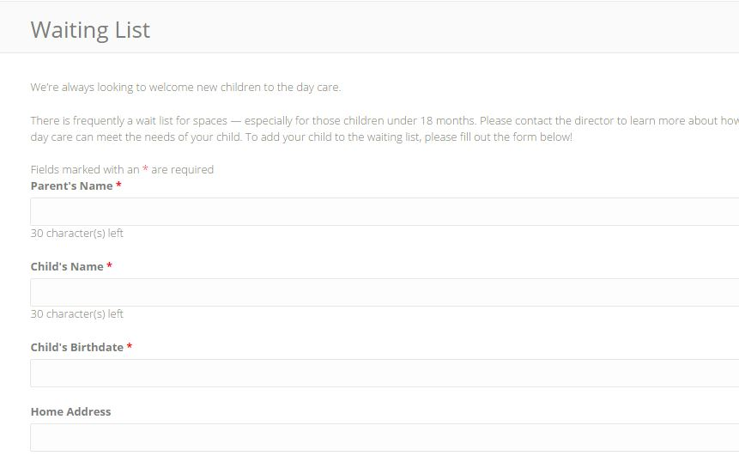

**Administration:**

Follow the steps below to make changes to the waiting list feature:

**To access the waiting list administration panel**

1- On the main administration panel on Wordpress, select “Forms”. Found in the left side menu bar. This section provides all the forms used on the website, including the “waiting list”.

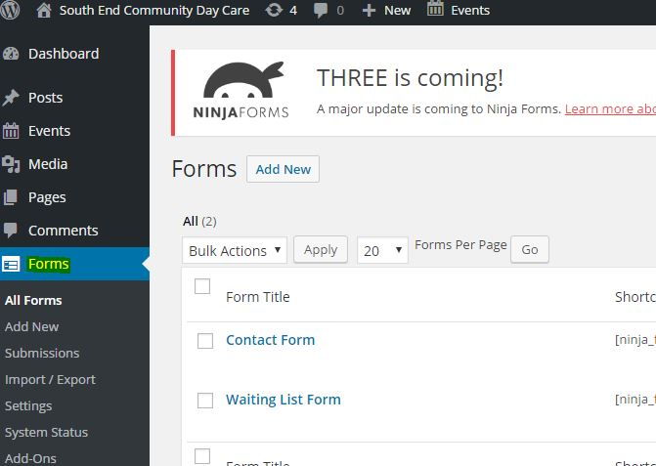

2- Hover the mouse over “Waiting List Form” or if on a smart device simply touch. Multiple text will be visible. Select “View Submissions” to view all the submissions in the system. All the data is organized in a clear table format.

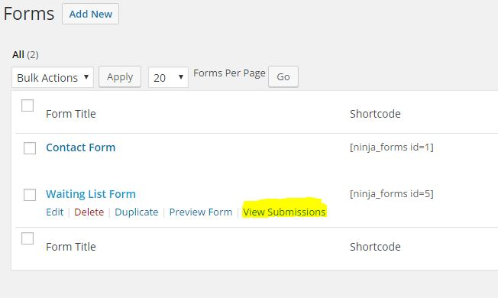

3- To view specific columns in the Submissions table, visit the “View submissions” page that was explained above in section #1. Click the “Screen Options” button at the top of the page.

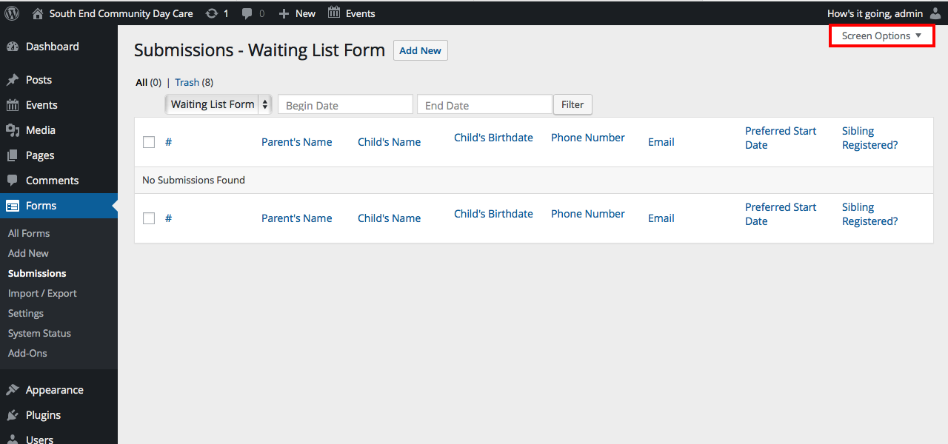  
After this, proceed to check the boxes of the columns you would like to view and click “Apply”.

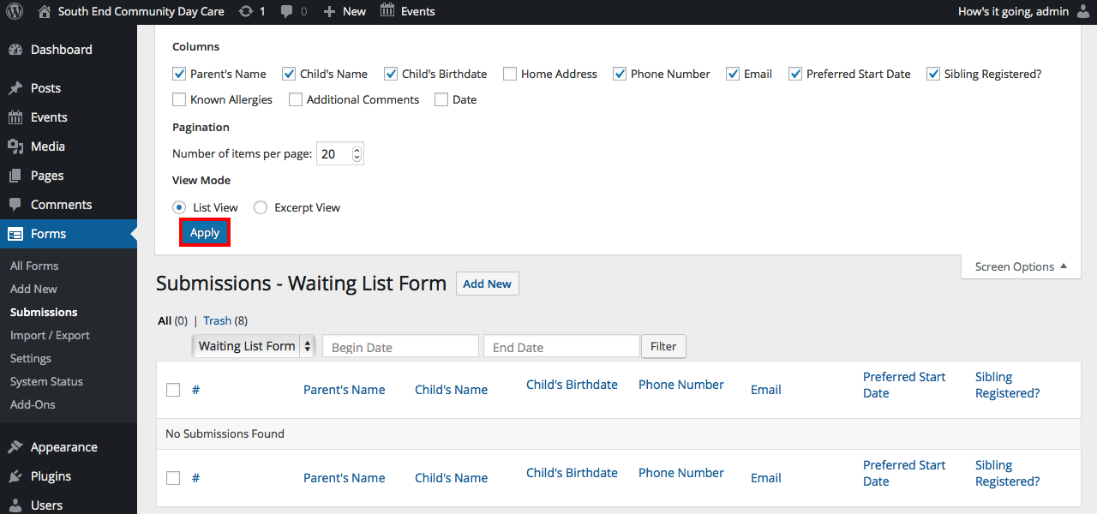

2- To update current data in the waiting list. Visit the “View submissions” page that was explained above in section #1. Hover the mouse on one of the submissions that require an update, and select “edit” found at the left side of the specific submission. Once there edit the text areas and select the “Update” button found at the right center of the page to save the changes.

3- To delete a submission in the waiting list simply follow the steps above in section 2. However instead of selecting edit. Select “Trash”.

4- To update the submission form fields, select “Waiting List Form” and finally “Build Your Form” at the menu located center of the page.

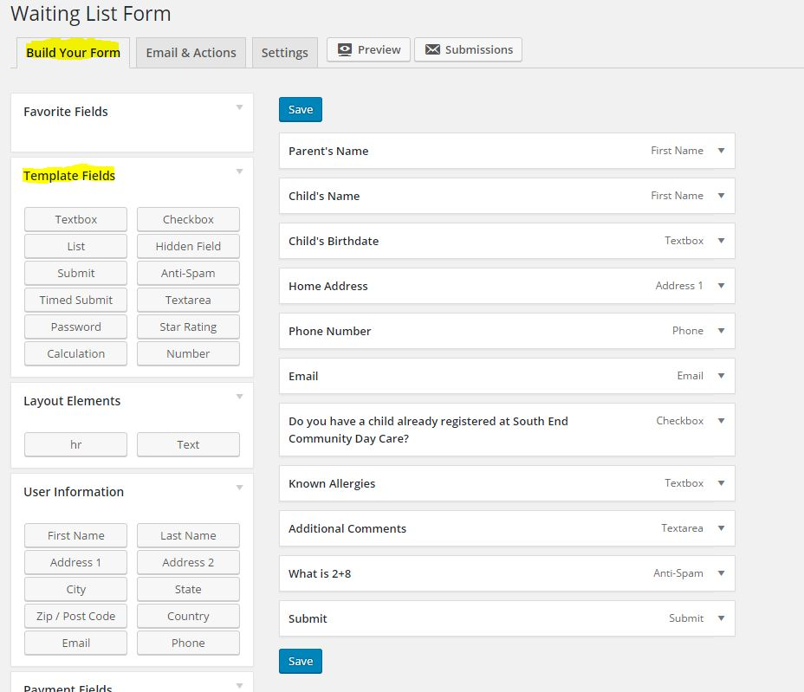

This panel is based on text boxes that represent the waiting list form that appears to users when they fill out the form. For example the box with the text “Parents Name”, represents the text area in the form “Parents Name”. The boxes in this page can be selected and dragged top and below other boxes which will represent the order of the text fields in the form. Furthermore to add additional components to the form simply select and drag one of the boxes at the “Template Fields” found at the left side of the page. These boxes are titled with what they represent, such as “Text area” , “submit” button, and “checkbox”. Once your drag the box of your choosing to the center of the page along with the other boxes. Select the box, update the field to represent the box and select the “save” button to save all the changes.

5- To update the notification email, select “Forms” in the WordPress administration panel. Once there, select “Waiting List Form” then “Email & Actions”, and finally “Notification of new Waiting List Entry”. This section is what handles the emails to the admin, when a visitor makes a submission to waiting list.

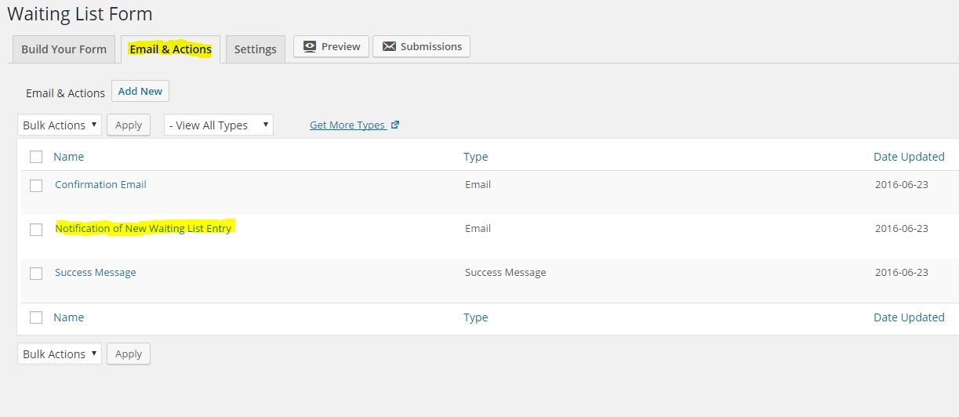

6- Fill in the text area’s to make any specific changes. The “To” area is the email that will receive the waiting list submissions. “Subject” refers to the Subject header of each email. And finally “Email Message”, which will provide detail of the submission, avoid changing this section, Tags refer to specific data. Ex. [ninja_forms_id=13].

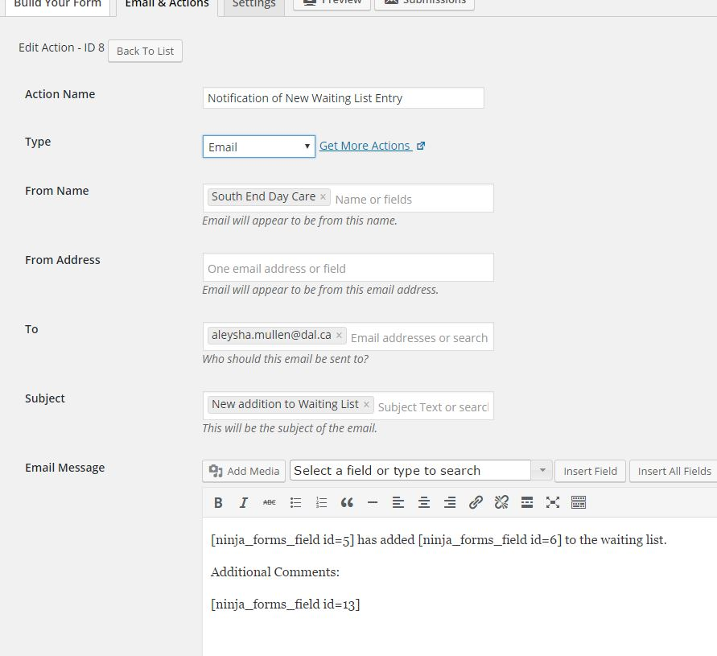

7- To change the response message to visitors after they submit the waiting list. Select “Email & Actions, and “Success Message”.

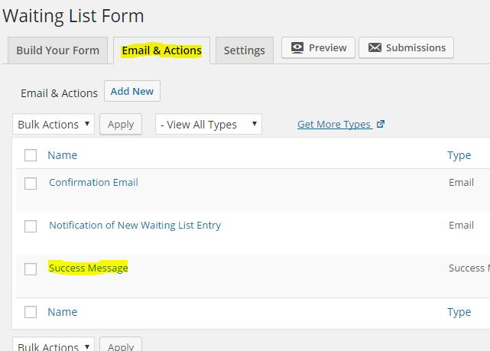

8- Fill in the specific text fields to make changes to the response message.